JUGENDHERBERGE WIEN
MYRTHENGASSE
1070 WIEN, MYRTHENGASSE 7 |  | 1070
TEL. +43 1 523 63 16, FAX +43 1 523 58 49
E-MAIL: hostel@chello.at
 | VIENNA
http://www.1070vienna.at
UID: ATU48997803 I ZVR: 564904988

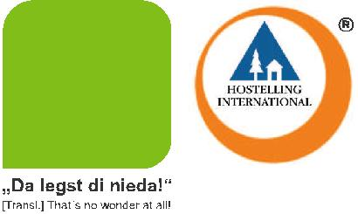
PREISLISTE 2015

PRICE LIST 2015

05.01.2015 - 08.03.2015 | 09.03.2015 - 08.11.2015
09.11.2015 - 27.12.2015 | 28.12.2015 - 03.01.2016

EUR 18,00

EUR 21,50

EUR 17,00

Nächtigung im Mehrbettzimmer mit Stockbet-ten pro Person/Nacht inkl. Frühstücksbuffet und Bettwäsche

Overnight rate in multi-bedded room with bunkbeds, per person/night incl. buffet-breakfast and sheets

Nächtigung im Zweibettzimmer mit Stockbet-ten pro Person/Nacht inkl. Frühstücksbuffet und Bettwäsche

Overnight rate in a twin bedded room with bunkbeds per person/night incl. buffet-breakfast and sheets

Zusatzbett/Frühstück

Extra bed/breakfast

EUR 19,00

EUR 22,50

EUR 18,00

Mittagessen, Abendessen (3-Gang Menü inkl. Salatbar, Wasser) in unserem Selbstbedie-nungsrestaurant je (nur Montag-Freitag)

EUR 7,00 EUR 7,00 Lunch, Dinner (3-course menu incl. salad-bar,

water) in our self-service restaurant each (only Monday-Friday)

1070
VIENNA

WWW.1070VIENNA.AT

For groups with a group size of min. 20 people, we offer special conditions.

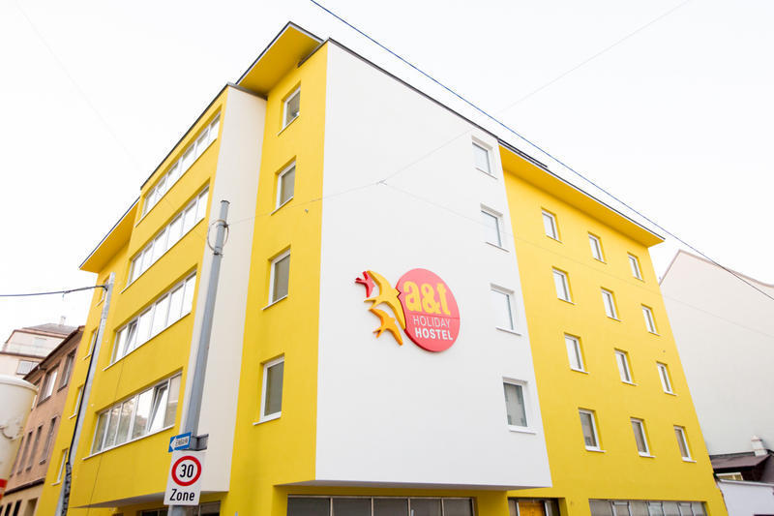
A&T Holiday Hostel
Leibnizgasse 66
A-1100 Wien
+43 (0) 1 60 70 727
+43 (0) 1 60 70 727 - 28
office@athostel.com
www.athostel.com

We have enough place for the groups. We are able to offer you the following prices:

27.03.-30.03.2015 (Oster Holiday)
1 Night per Person in 4/6-Bed-room 22,- €
1 Night per Room in 3 Bed-room 75,- €
1 Night per Room in twin room 58,- €
1 Night in twin room single use 58,- €
1 Night in deluxe twin room with panorama view 68,- €
1 Night in deluxe twin room with panorama view single use 68,- €

The specified low prices are valid for 1 week.

Breakfast is an “all you can eat buffet” not included and costs 4,80 €
Of course you can book the breakfast in advance.

We can also arrange 2-course lunch or dinner for the group for only 10,- € per Person (possible for groups of 20 persons and more).
A 3-course meal is also available – for the price 12,- € per Person. Vegeterian and glutanfree meals are also available.
Water for drinking is included in the price. The meals are always in form of an „all you can eat“ buffet and are served warm.

The reservation is assured after access of down payment of 50% on our account.
The outstanding payment must be paid by arrival.

Cancellations and Changes:
- up to 42 days before date of arrival are free of charge.
- up to 28 days before date of arrival, 50% of the total price of the reservation.
- up to 14 days before date of arrival, 70% of the total price of the reservation.
- that are delayed, as well as No-Show will be charged the full amount.

Westend City Hostel
Fügergasse 3
1060 Wien/Vienna
Austria
Tel.: 0043-1-597 67 29
Fax.: 0043-1-597 67 29-27
www.westendhostel.at
info@westendhostel.at

Our WESTEND CITY HOSTEL is the most centrally located international youth hostel right in the center of Vienna. Our prime location in the old town of Vienna, close to the Westbahnhof (western railway station) and Innere Mariahilfer Straße (the largest shopping boulevard in town) enables you to get to most historical sights, restaurants, theaters and clubs on foot or by public transportation in no time!
We would still have free capacities in the mentioned period.
Check-In: 27.03.15
Check-Out: 30.03.15
We can offer you:
up to 10 people:
4-bedroom EUR 25,90
more than 10 people:
6-bedroom EUR 25,90
8-bedroom EUR 20,90
10-bedroom EUR 18,90
The prices* are per person and night incl. continental breakfast,
*no responsibility is taken for the correctness of this information
For a stay of only 1 night we charge a EUR 2,- fee for the cleaning of the bed linen for all dormitory beds!
WE HAVE NO CURFEW AND THE RECEPTION IS OPEN 24 HOURS!
Check in time is 3:00 p.m., but if you arrive earlier you can store your luggage in the hostel free of charge
All rooms are equipped with bunk beds, lockers, shower and WC
Cat. A. is a four-bedroom, which you book as a single or two-bedroom (for a higher price).
Cat. B is smaller than Cat. A rooms and has a window to an airway which also serves as elevator shaft. The elevator will be shut down at10pm.
As we calculate our prices per bed we reckon for any bed the full price which remains unused due to changes of the number of persons.
You can buy towels for 4,00 EUR and padlocks for 3,00,- EUR or you bring them yourself.
Busparking: 39,- EUR / 24 h (Please purchase tickets beforehand at the reception!)
Gaudenzdorfergürtel 77, A- 1120 Wien

After your reconfirmation we may ask you for a prepayment.
Amount and term of credit will be forwarded to you in time.
If you are interested in a reservation, we would ask you to let us know a.s.a.p.
Cancellation fee: Part or full cancellation must be in written form and may arrive us AT LEAST 3 months before arrival. If the deadline was not kept the cancellation fee is to be paid per person for all ordered services as listed: at least 3 months before arrival: Free of charge, 40% by 3-1 month, 70% by 1 month- 1 week, 90% within the last week, 100% of the total price on the date of arrival.
These rules also apply if individual travelers withdraw from a group or are unable to travel without notice!
With the written reservation the customer accepts the terms of reservation and cancellation of the Westend City Hostel Ltd. The application is also made for all fellow passengers through the customer who is responsible for their compliance of contract. A guaranteed reservation will only be achieved through a written booking confirmation of the Westend City Hostel Ltd.
Terms of business Westend City Hostel:
http://www.westendhostel.at/reservierung-ab-8-personen/
As far as nothing else is arranged the general conditions of hotel business (AGBH) from November 15th 2006 are valid.http://www.hotelverband.at/down/AGBH_englisch.pdf
Further information you also find here: www.westendhostel.at

